**Chapter 1**

Evaluate Using Order of Operations. [L2]

1.) $2(3+7)-5^{2}$ 1.____-5_________

2.) $\left(1+7*5\right)÷(10-4)$ 2.____6___________  
  
  
Solve for the indicated variable. [L2]

$3.) Solve for m: q=\frac{3}{4}m-4$ 3. $\frac{4}{ 3}\left(q+4\right)=m$___ ____  
  
  
4.) $Solve for w: H=4wn$ 4. $w=\frac{H}{4n}$____ ______   
  
  
5.) $Solve for x: 4y=\frac{xt}{2}$ 5. $x=\frac{8y}{t}$__ _______  
  
  
Solve the Expression for x. [L2]

6.) $2\left(5x-1\right)-6x=18$ 6._____x=5________

Solve the Expression for x. [L3]

7.) $x^{2}=81$ 7.___x=9 or x=-9_____

Solve the equation. Check for extraneous solutions. [L3]

8.) $7\left|x-1\right|=70$ 8.___x=11 or x=-9____

Write an Equation and Solve. [L4]

9. 9._________________

**Chapter 2**

Identify the domain and range. Then tell whether the relation is a function.[L2]   
  
1.) {(18, 21), (-1, 10), (3, -6)} 1. Domain: __18, -1, 3__   
 Range _21, 10, -6__   
   
 Function? _yes___   
Decided whether the given function is linear, then evaluate it for the given value of x. [L2]

2.) $f\left(3\right)when f\left(x\right)=5x$ 2.___f(3)=15______

Write in Slope Intercept Form [L2]  
3.) $9x+3y=21$ 3. $y=-3x+7$

______

Find the slope of the line through the given points. Then write the equation for the line. [L3]

4.) (6, 8) and (4,2 ) 4. $m=3 and y=3x-10$

______

Graph the following equations. [L3]

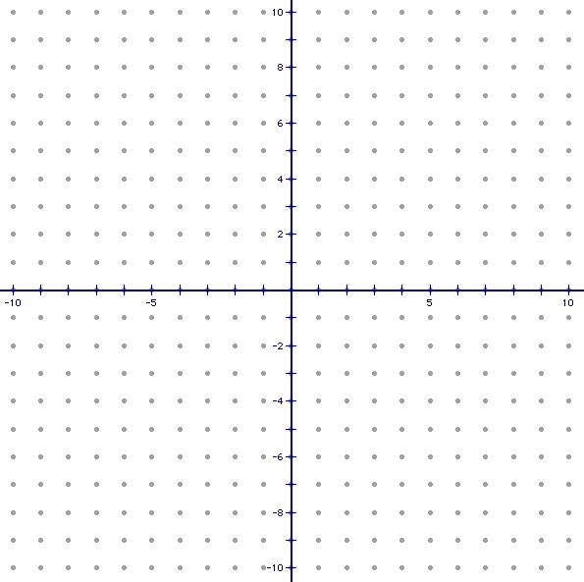5.) -2y +5x = 12 5.

Choose to answer one of the following. [L4]

6.)

**Chapter 3**

Solve the following systems using any method. [L2]

$1.) x-2y=3$ 1.

$y+3x=-5$



$2.) -2x-5y=-11$_________________

2.

$9x+5y=-3$

_________________

Solve the System. [L3]

3.) $3x+y-2z=22$ 3.

$$x+5y+z=4$$



$$x=-3z$$

_________________

Solve the following system. [L4]

4.) 4._________________

**Chapter 4**

Write the following in Standard Form. [L2]

$1.) y=\left(x+2\right)(x+1)$ 1. $y=x^{2}+3x+2$ $2.) y=\frac{1}{4}\left(x-2\right)(x-6)$_____  
  
  
 2. $y=\frac{1}{4}x^{2}-2x+3$

____

Graph. [L2] Graph. [L3]





$3.) f\left(x\right)=-({x-1)}^{2}+2$ $4.) f\left(x\right)=x^{2}+6x+3$

Factor the expression completely. [L2]

5.) $m^{2}+ m-6$ 5. $(m+3)(m-2)___$

__

Solve the Equations Using Any Method. [L3]

6.) $x^{2}+9x = -20$ 6. $x=-4 and x=-5$

___

Solve the following. [L4]  
7.) 7._________________

**Chapter 5**Describe the Polynomial

$1.) f\left(x\right)=x^{5}+3x^{3}-4x$ Degree: _5_ **[L2]**Type:_n/a__**[L2]**  
Leading Coefficient: _1_ **[L2]**  
Total Number of Solutions: _5_ **[L2]**  
Y-Intercept: __0_ **[L2]**  
List of Possible Rational Solutions: ____________________ **[L2]**  
Right End Behavior: _up__ **[L2]**  
Left End Behavior: __down__ **[L2]**Find all zeros (Show your work). __x=0, x=1, x=-1,x=2i, x=-2i__ **[L3]**

Write in standard form a cubic polynomial function with leading coefficient of 1 with zeros [L2]

2.) $-4, -2i$. 2. $x^{3}+4x^{2}+4x+16$

____

Find the zeros of the following function. Multiplicities? [L3] $3.) f\left(x\right)=x^{4}+7x^{3}+10x^{2}$  
? 3. $x=0 (mult 2) x=-5, x=-2$

___

Solve the following. [L4]  
4.) 4._______________